**Assignment 1 3P94**

**Dave Bockus**

**February 2nd 2023  
Group 16**

Monty Oshinov - 6759286

Eduardo Saldana - 6612626

Goktug Hizir Cirag - 6776678

**Introduction:**

For the purpose of this assignment we will be taking a look at 3 popular DIY PC builder websites: [Xidax PCs](https://www.xidax.com/desktop/x-4), [Newegg PC Builder](https://www.newegg.ca/tools/custom-pc-builder), [PC Part Picker](https://pcpartpicker.com/list/)

**Websites broken down by their components:**

**PC Part Picker:**

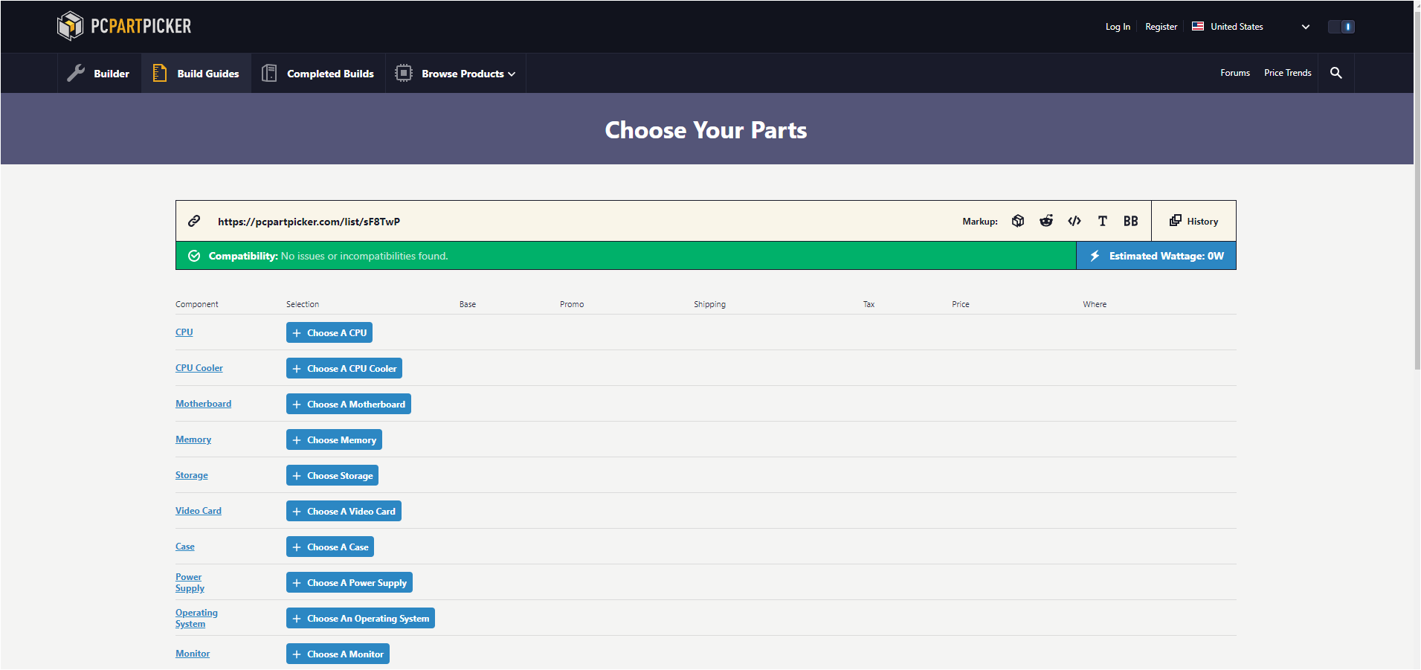

PCPartPicker Services:

* PC builder
  + Lets you choose PC parts
  + Lets you see the prices of each part
  + Lets you toggle a mode that only allows you to see parts that are compatible with every other part
  + Lets you filter by price, brand, manufacturer, rating, etc.
  + Lets you see the prices of the item on each individual storefront to compare
  + Has links to buy the parts from the storefront directly or a button to buy everything all at once from the PC:PP website
  + Shows you a part list price history to see the price of parts over time
  + Shows the estimated power consumption of the build
  + Has links at the top and share buttons so you can share your build
  + Has buttons to save builds or start new ones

PC Part Picker Critique:

PC Part Picker is a website that is designed to let you pick the different components of a PC in order to plan out a PC build. You are able to see the differences between these components such as the brand, type, size, price and other factors. You can filter out parts based on these criteria as well. The website also has other features to assist in choosing PC parts. The site lets you see if the parts are compatible with the parts you have chosen currently and allows filtering out parts that aren’t compatible. You are able to check the possible wattage of the chosen parts to see what the power requirements are so you can choose a power supply that has adequate wattage. The website also lets you save your build or share it by sending a link to it. This can be used for many reasons such as asking for help with a build.

There are some things that could be improved on. When you click a PC part to select it reloads the entire page, this is inconvenient and slow and could be improved by not requiring to reload the page until a part is actually picked. The website could also explain what each part is and why it was important to help inexperienced users. The compatibility chart is useful but sometimes it does not adequately explain the compatibility issues from 2 parts so it is hard to see what the issue is, this happens to parts that pass the compatibility filter which is inconvenient, this could be fixed by having different compatibility filters that are more strict.

**Pc Part Picker HTA:**

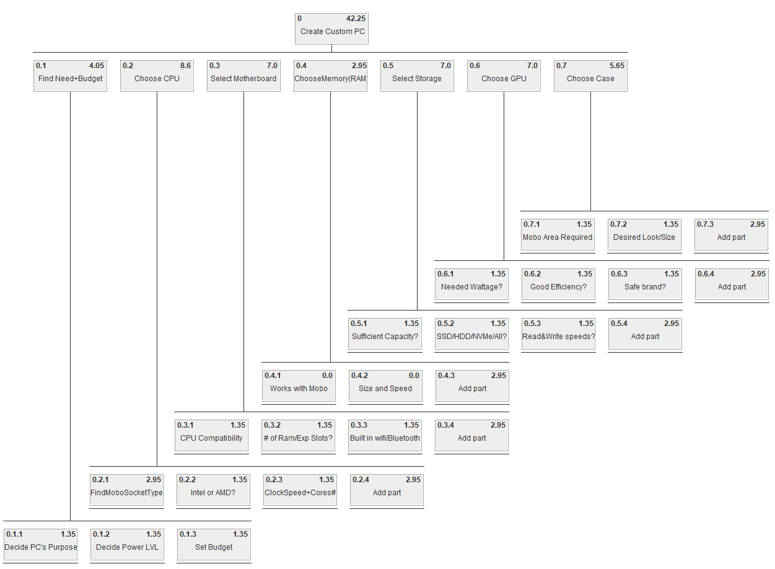

**Newegg:**

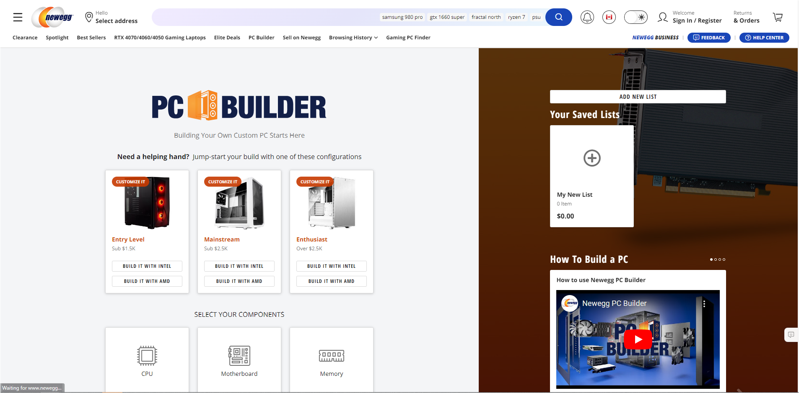

Newegg Services

* Offers sales for various computer products:
  + Prebuilt computers
  + Computer parts
  + Software
  + Peripherals
* Offers clearance sales and deals for some products that constantly update
* Reviews for items in the store:
  + Anyone who has purchased an item can rate and write a review for that item.
  + Shoppers can look at how other users who have purchased items from the store rate those items.
  + Shoppers can also read details on why that user rated the item that way for more information
* DIY PC Builder
  + Can save groups of items together as “builds”, helping organize items needed to build an entire computer.
  + Sidebar shows what types of parts the user has and has not purchased that might be necessary or desired for a particular build.
    - Can look at parts in that category from the store, showing the same deals and reviews that are available on the store.
    - Various filters are available (Price, make, etc.).
    - Sort by price, rating, product specifications, etc.
    - Search engine for parts.
    - Can select items and they are saved onto the build under the appropriate part category.
  + Builds automatically check for compatibility to ensure a build will work, and filter out incompatible parts.
  + Gives cost summary.
  + Can add all parts to the shopping cart at once.

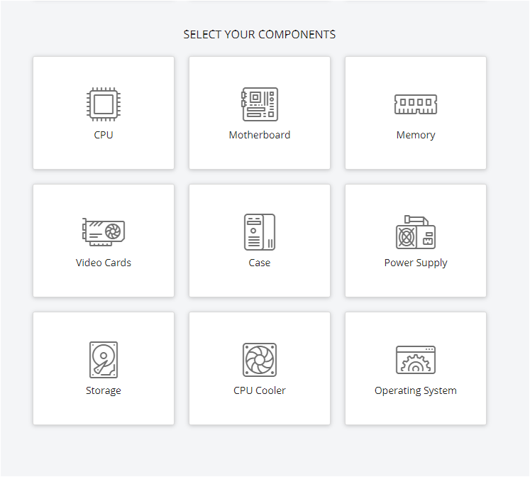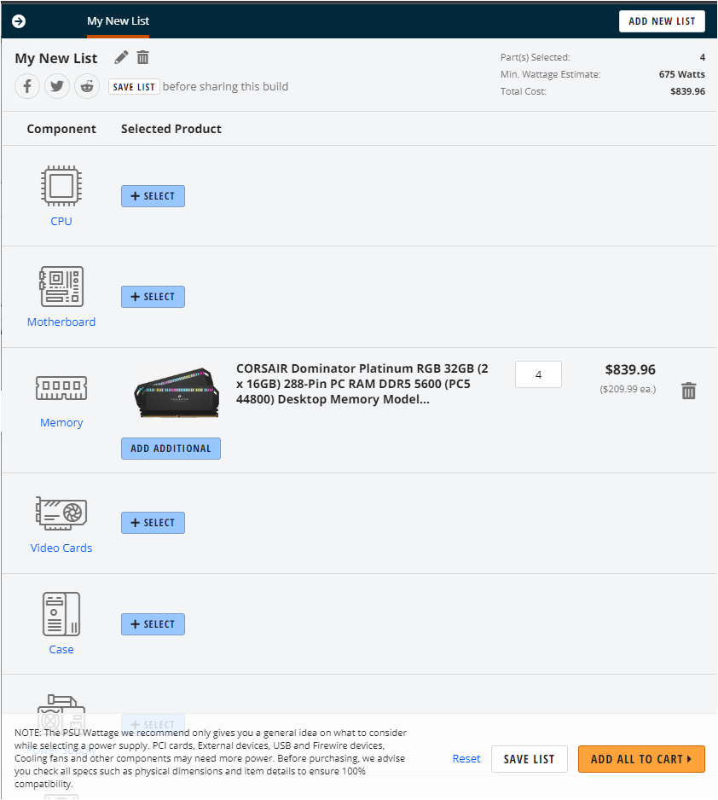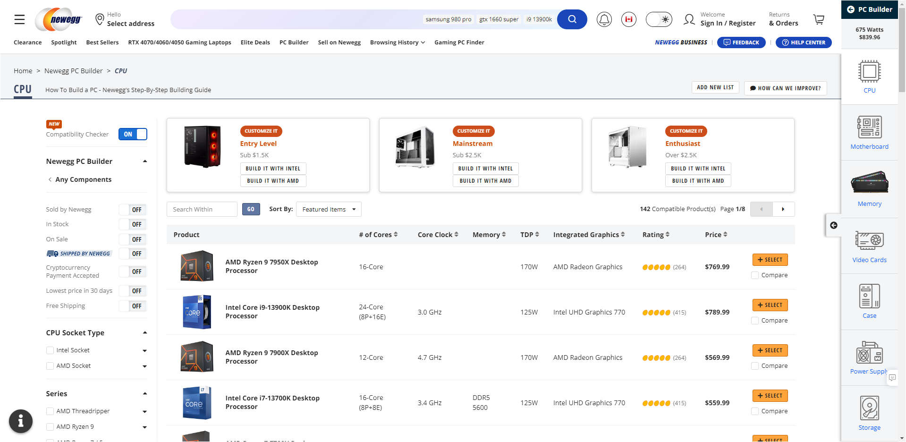

**Newegg HTA:**

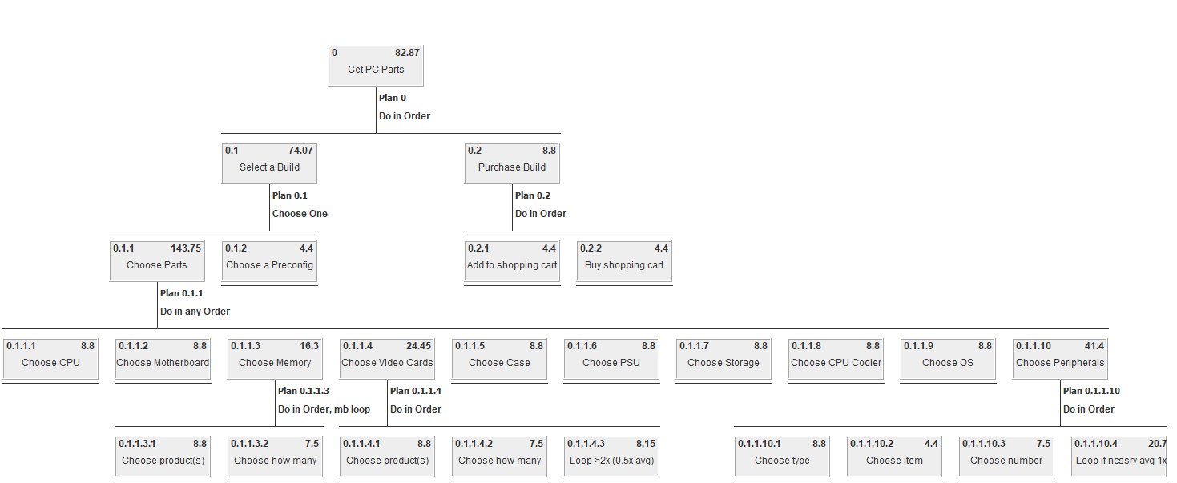

Newegg is an online store for computer parts, software, and accessories. It provides a DIY PC builder which allows users to plan out a custom computer build, the store itself, and customer service links and options. The store itself includes a system for rating and reviewing items, a shopping cart, and daily deals.

The PC builder is a vital part of Newegg, allowing users to group parts together into builds, filtering out incompatible parts, and guiding the customer to include a complete set of hardware and possibly software. Though it is a well-made and helpful tool, the only way to reach it is by clicking on “PC Builder” in tiny font on the navbar of the website, which provides no pictures and is crowded with other information and links, making it relatively difficult to arrive at the page.

Newegg provides a number of customer service options including email, phone, and chat options to connect users to people to help guide them through any trouble they may be having with products or with building a computer. This is important, since many people who are first time builders will have trouble with knowing what is necessary for their build. The chat can provide a sense of security about decisions these beginners make, and bring more first time builders onto the website. Despite this, however, Newegg does not advertise their ability to provide technical support and product advice, burying the option deep in their customer service page, which itself can only be accessed from the problematic navbar. This requires entirely leaving the PC builder part of the website, which is why it was not included on the HTA.

**Xidax PC:** 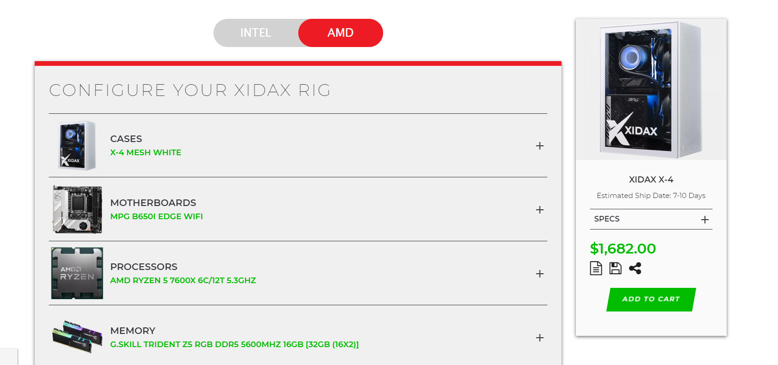

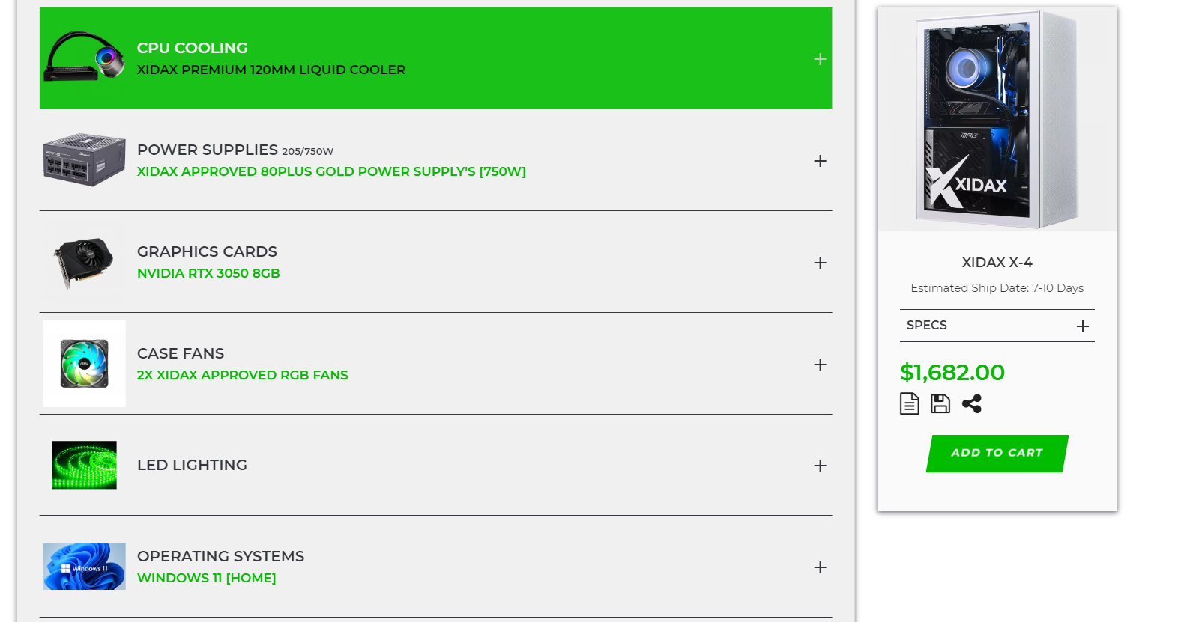

Services XIDAX PC:

* Leave a rating:
  + Let the user leave a rating
  + Lets the user check out other reviews on the PC they have bought

- DIY PC part builder:

- Lets the user pick out part by part which components their PC will have.

- Gives a breakdown on how much each component will cost

- Gives the option to include additional non-essential hardware like a keyboard or a monitor for an extra charge.

- Gives option to save the currently being worked on PC to access it again later

- Gives Breakdown of the Specs the PC will have with the currently selected components.

- Lets you generate a link to share your custom build PC with others

‘

**XIDAX HTA:**

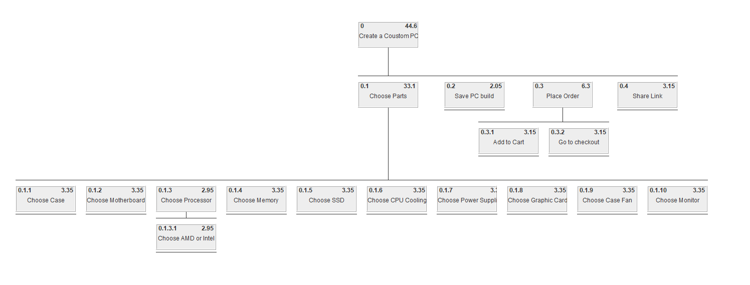

Xidax Site Critique:

The Xidax build your custom PC website does a good job at offering a simple interface so even a user with very little experience or knowledge at building PCs can get through it without much trouble. It also does quite a good job at stating which components are available to get, their pierce and whether or not they are essential to the PC (some components such as keyboards or mouses are optional).

There are quite a few problems with the design of the website however, the most noticeable being that the website lacks adequate description of each component. While just the name might be enough for experienced people, for any person that does not have some knowledge in tech just providing the name of each component and their price provides very little information and simply prompts the user to have to either leave the site to research each component individually or simply choose what is in their budget rather than what it is the best option for them.

The second noticeable problem with the website is the lack of communication of what is possible to build with the user. What this means is that when components are not compatible with each other the user has no way of knowing until they choose a component and they are displayed a message informing them that the component they choose is not compatible with their current PC build so they have to either forfeit picking that component or go back to change past decisions.

Overall the site is more aimed towards inexperienced users as it's clear the site puts a heavier emphasis on what the components cost and offers extras such as webcams, keyboards, etc, but lacks when it comes to putting an emphasis on the PC performance.

**6. Survey Results**

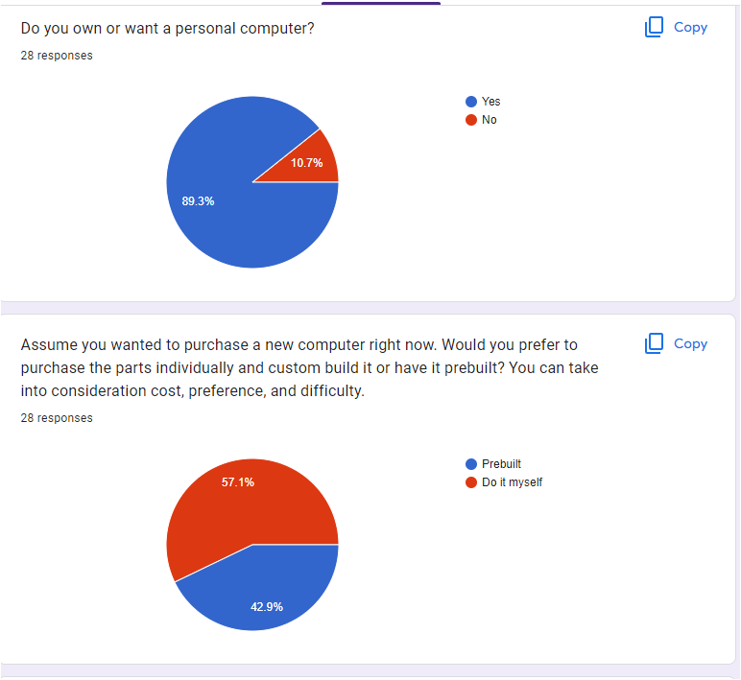

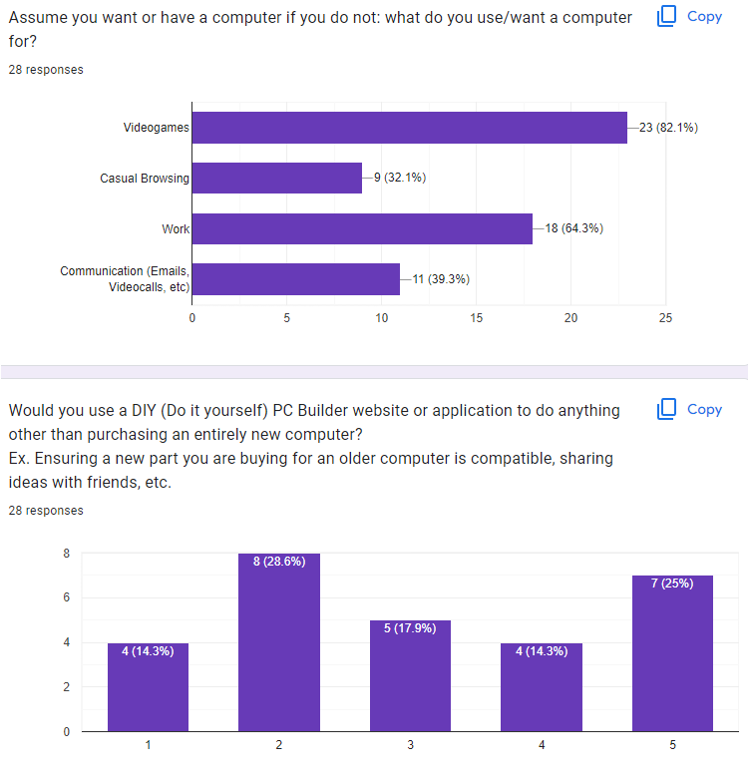

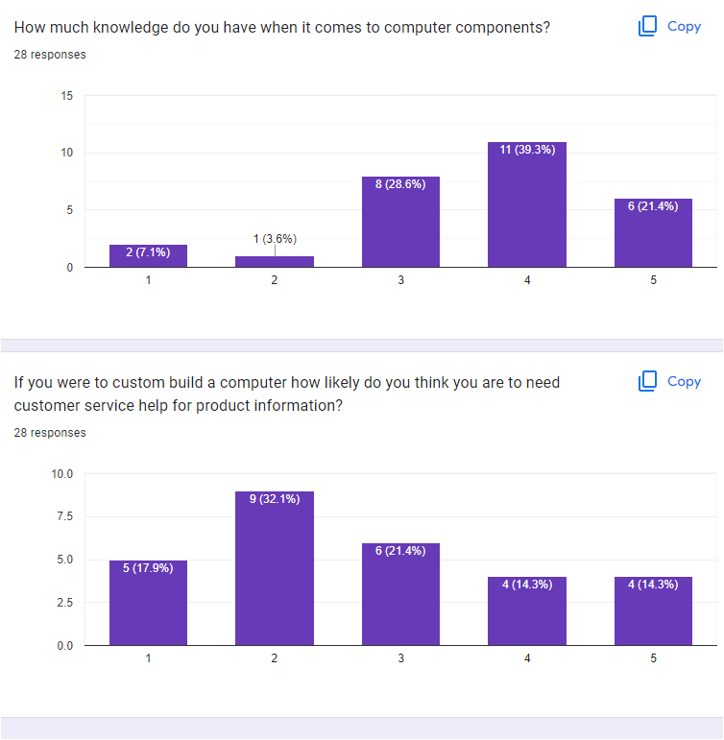

**7. Personas:**

Arnold (23M):

Just finished a college diploma at his local community college for systems engineering. He is very comfortable with technology, and knows all about computers. He used to love video games, but as he’s grown up he has less and less time to play. Nowadays he’s adopted unrelated new hobbies like working out and baking. His family often asks him to fix their internet. His social skills are poor and he avoids customer service if it’s ever possible.

Joey Johnson (15M): (Primary persona)

Young but loves PC gaming. Owns an extensive collection of games but wants a computer that can run those games. He owns a PS4 and plays a lot of games on it but now that the new consoles have come out he has decided to get a new PC rather than get a PS5 as he doesn’t like the Playstation Exclusives that much. He wants a brand new PC to play the latest and greatest games.

Mandy (38F):

Graphic Designer and Photo Editor that has little interest in video games. Needs a powerful PC in order to do her work. Does not like Apple or iMacs and thus prefers Windows PCs. She needs a powerful PC as the programs and work she does is very intensive on PC components.

Courtney (24F):

Courtney is an aspiring Twitch streamer. She saw how much money some streamers make and is now considering dropping out of school if she can make it big. She is looking for new hobbies to adopt and stream about. She has impulsive tendencies, but works hard to get what she wants. She needs a powerful PC in order to play games at the highest settings and stream in the highest quality.

Timothy (14M):

Timmy likes going on the family computer to watch videos. He also uses it for schoolwork. Timmy is a serious kid and has no interest in getting his own personal computer. He wants more time to work out for his dream of being an American Football player in the NFL. As a backup he’s wondering what he should go into college for, but is struggling to find his way.

Juan (21M): (Primary)

Construction worker who is the best DPSer in his Destiny 2 guild. He likes playing video games. He lives with his parents, but has started working to afford his gaming life. Juan wants to start playing on PC because none of his friends use Playstations anymore, and is currently saving up for a powerful build. He knows very little about computers and keeps asking his friend Arnold for advice.

Akira (49F): (Primary)

Akira immigrated recently along with her husband and son and is looking for a computer to browse the internet in her free time. She has a work visa working for a bank. After moving to Canada, she has had a huge pay raise working for the main branch of her bank. She misses her parents in Japan. Akira doesn’t have much free time, so she’s thinking of getting her son a computer to play with while she’s not around.

Robert (99 M):

Just use the computer to read the news and browse facebook. Tries to also use his computer to stay in touch with his granddaughter. He has been feeling very lonely after his late wife passed away. He wants his children to visit more often, but understands they don’t because he worked too much in his younger years and didn’t put enough effort into connecting with them. He struggles to understand how to use a computer but is putting in effort since he believes it can get him closer to his remaining family. He wants to get whatever computer is the cheapest because his pension leaves him on a tight budget.

**8. Primary personas:**

Juan

In order to get the primary persona to use the website and find it appealing we need to make sure that when presented with the option to build a PC we outline specifically the price and specification of each component so he can shop within his budget while making sure the PC components are strong enough to run the games he wants to play at the desired resolution and frame rate. The website should also not overcomplicate the description of the components to not scare him away.

Akira:

Since Akira is not very well-versed with computers she would need help with something like custom-building a computer. She loves her son, however, so she wants to do something really special for him and is willing to put in the time and effort. Her goal is to build a great computer for him. To achieve this she’ll need help from experts to build her computer, but since she’s newly immigrated, Akira does not know who to ask. Good customer service advice is necessary for Akira to be able to complete her goal. Akira also needs everything to be easy to understand and interact with so she can feel assured that she’s buying all the necessary parts she needs.

Joey Johnson:

Joey Johnson is very interested in PC gaming and watches videos that talk about PC gaming and PC building as well as reviews on PC parts. He will want to build the PC by himself by buying all the parts and assembling them. He will likely want to use a website to plan out his PC build in order to make sure all of the parts are compatible. He is also part of PC gaming communities such as on Reddit and thus will ask them for help for building his PC. He would want to use the website to make it easier for people to give advice.

Secondary Persona:

For the secondary persona it is important to keep in mind that most of them are mostly concerned with not going over budget for their computer. This can be addressed by having an option to filter by price so those with a tight budget still feel comfortable building their own PC. Just like there should be an option to filter by price there should also be an option to get suggested parts for the customized based on the currently selected parts.

**9. How and where will our website be presented?**

We will be creating a web application for the purpose of this assignment. We will use React and bootstrap for creating the frontend of the website. It will be available on PC.

**10.**

**DIY PC Builder:**

The DIY PC builder page opens up the components store on the left with a list of possible and chosen computer parts on the right. Items incompatible with the current build will be removed from the store page. When people see the items on right, they’ll think to click on a particular item type there to search for it, so to create a natural mapping, clicking on those parts will search the store automatically. The question marks on each item can be clicked to describe basic info on that part that first-time builders might need.

Storyboard:

Front Store Page:

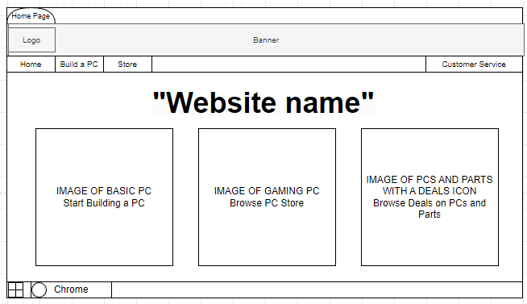

The front page will display the website's name in a big font and present the user with 3 main options. Firstly the option to start building a PC, which will take the user to the page to start making their PC. The second option would be to browse an already prebuilt PC for customers who do not wish to create their own PC. The last option is to browse PC deals such as discounted built PC’s and PC components as well. The aim for this page is to be a simple introduction to the website and present the user with options.

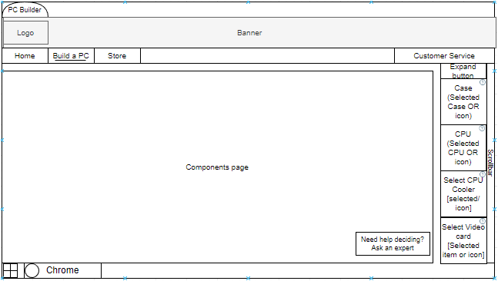

The right sidebar can be expanded to show additional options and info, including more information on items you have chosen, and options to share or purchase your build. The idea for this kind of sidebar was borrowed from Newegg. Icons for different types of parts will need to be accompanied by written words to account for differences in semantic knowledge and cultural constraints, since people unfamiliar with computer parts or from other cultures might not recognize these.

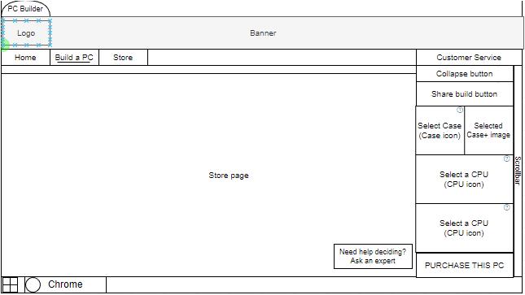

This layout includes a button to ask an expert for help, which will expand options to either chat or call an expert for help with building a PC. This will help amateur or first-time builders like Akira, Joey, and Juan understand what parts they need. Additionally, they’ll be further supported by the sidebar which guides them through what parts they might need for a complete build. Juan can even use the share build to share his build with Arnold so he can check it.

Customer service screen:

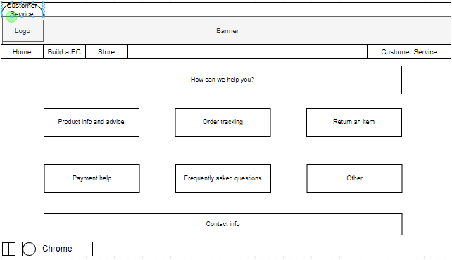

The customer service screen includes a few categories of concerns users might have while using the website. Product info is the first on the list since our primary personas are likely to have an interest in this. The button for support is easily visible on the navbar too, since the navbar is kept intentionally uncrowded. The page somewhat relies on cultural constraints, since the contact info is at the bottom of the page, a common practice among websites. This list of common reasons for contacting customer support is an idea taken from Newegg.

Component/Prebuilt PC store:  
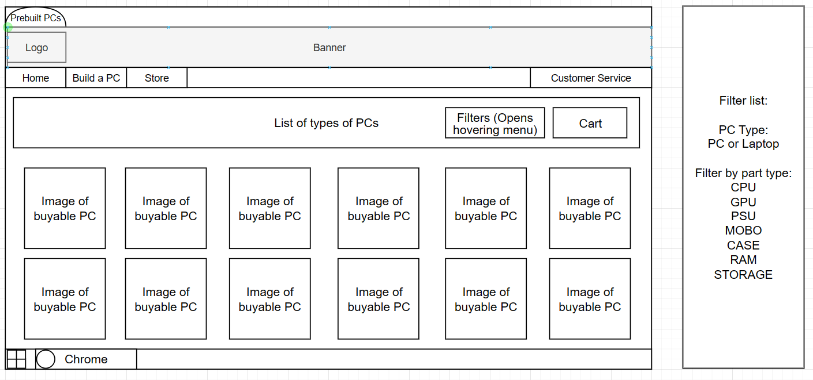

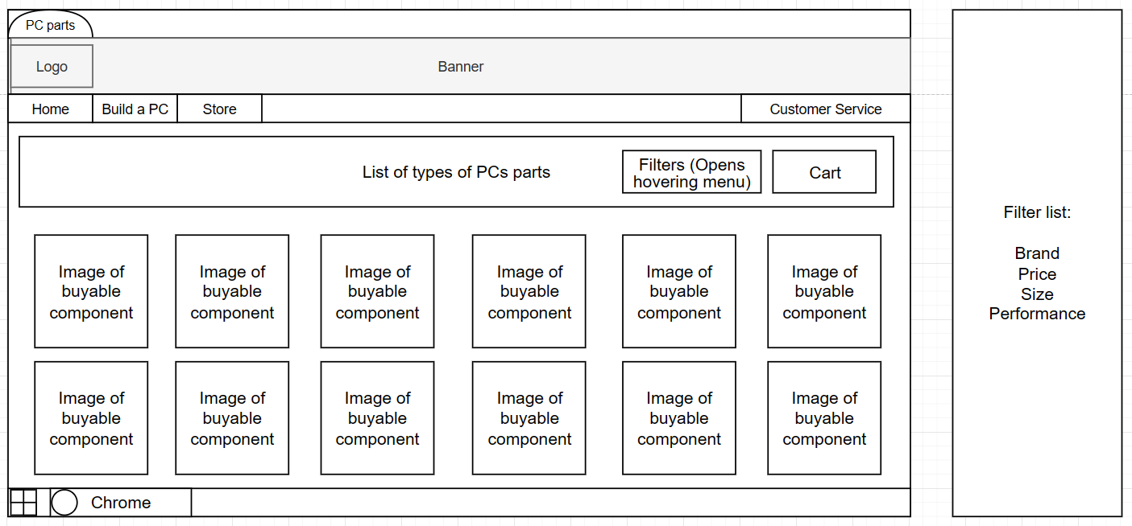

The store will be selling prebuilt PCs in addition to letting users choose and build their PC on the website. The website may have already built PCs that are not meant to be modified in the website or that a user can choose one of these PCs and modify it before ordering it. There is also a separate store for individual PC components. In case the user only wants specific components instead of having an entire PC prebuilt they can buy the components from here. The top filter button and group by type list were ideas borrowed from the airbnb website. The filters are a button with a popup-hovering menu. This is in order to take up less screen space while browsing and be less overwhelming. You can only see the filter screen if you actually want to and it requires you to press the button. The filter button is visible to users where they know if they press it they can filter out results making this a type of affordance. If you had a filter button on the screen at all times it could confuse some users and they may not notice that it is a filter menu but since the filter button requires you to press it to see filters, making it easier to understand this helps them figure out these afforded features.